

American International University-Bangladesh (AIUB)  
Department of Computer Science  
Faculty of Science &Technology (FST)  
Summer 19_20

Section: A  
Software Quality Assurance and Testing

Developing a test Plan for Road Spikes in Traffic Signal

A Report submitted

By

|  |  |  |
| --- | --- | --- |
| SN | Student Name | Student ID |
| 1 | Zannat, Rahikul | 17-33962-1 |
| 2 | Sakib, MD | 17-33659-1 |
| 3 | Jahan, Nusrat | 17-34151-1 |
| 4 | Sagar, Shamimur Rahman | 17-34146-1 |

Under the supervision of

Abhijit Bhowmik

Associate Professor & Special Asst., Office of Student Affairs at American International University-Bangladesh

Software Test Plan

for

<Road Spikes on Traffic Signal>

Version 1.0 approved

Prepared by <Zannat,Rahikul

Sakib, MD

Jahan, Nusrat

Sagar, Shamimur Rahman >

<American International University-Bangladesh>

<22/9/2020>

Table of Contents

Revision History 3

1. TEST PLAN IDENTIFIER: RS-MTP01.3 3

2. REFERENCES 3

3. INTRODUCTION 4

4. REQUEIREMNT SPECIFICATION 5

4.1 System Features 5

4.2 System Quality Attributes 6

4.3 System Interface 7

4.4 Project Requirements 8

5. FEATURES NOT TO BE TESTED 9

6. TESTING APPROACH 9

7. TEST CASES/TEST ITEMS 10

8. ITEM PASS/FAIL CRITERIA 12

9. TEST DELIVERABLES 13

10. STAFFING AND TRAINING NEEDS 14

11. RESPONSIBILITIES 14

12. TESTING SCHEDULE 14

13. PLANNING RISKS AND CONTINGENCIES 15

14. APROVALS 15

# Revision History

|  |  |  |  |
| --- | --- | --- | --- |
| Revision | Date | Updated by | Update Comments |
| 0.1 | 19/9/2020 | Jahan Nusrat | First Draft |
| 0.2 | 20/9/2020 | MD Sakib | Desing Testing |
| 0.3 | 21/9/2020 | Rahikul Zannat | Testing Complete |
| 0.4 | 22/9/2020 | Sagar, Shamimur Rahman | Feedback |

**1.Test Plan Identifier:** Road Spike on Traffic Signal_01.3

**2.Reference:**

* http://www.ijarse.com/images/fullpdf/1523793820_PG706ijarse.pdf
* https://eci-illinois.com/vehicle-traffic-control-spikes/
* https://www.rijse.com/wp-content/uploads/2019/12/Traffic-Signal-Automation-using-Spike-Road-Block.pdf
* https://www.rsisinternational.org/Issue0/issue8/645-650.pdf

**3.Introduction:**

The traffic congestion problems are increasing day by day because of the increasing number of vehicles with limited infrastructure. In this situation, the existing traffic light systems which are time based are not able to control traffic. To overcome from this problem, a real time traffic control and monitoring system by using road spike block. For effective traffic management and signal control, it is important to know the road traffic density. This test plan describes the testing approach and overall framework that will drive the testing of the Road Spike on Traffic Signal.

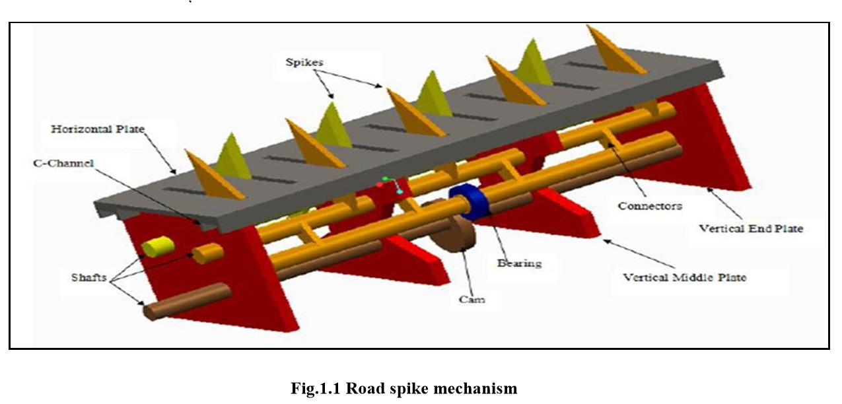

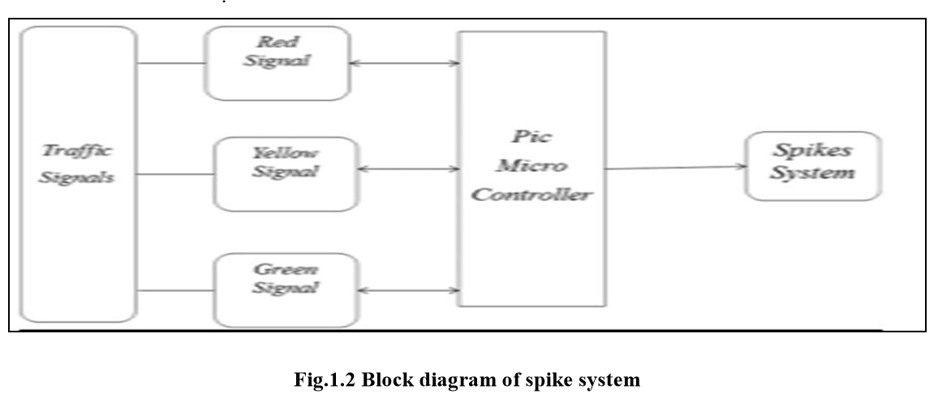

A road spike system is used for various applications like traffic controlling according to density present on the road, for BRT to avoiding non permitted vehicle entering, on the way road, security system. The main object of this system is to stop the vehicle at signal and also restrict the vehicle which is entering in to the BRT road. This system can be used in the retractable spikes before the zebra crossing and comes out when the traffic signal is red and goes off when the traffic signal turns to green. In the usual traffic system the peoples were not following the traffic rules properly. It will make all the people to obey the traffic rules correctly.

**4.Requirement Specification:** To setup this system in our country we need to follow some criteria and feature. Here are some major system functional requirements that describes the system functionalities.

**4.1 System Features:**

1. System log in section to start the process.
2. System provide service 24/7.
3. User must need a valid username and valid password and user valid mobile number to log in.
4. For confirmation, system send a code to user mobile number.
5. If user given wrong username or password in three times, then the system will be stopped log in process for 10 minutes.
6. System control traffic signal light.
7. System control spike control unit.
8. System control User.
9. System control Main control unit.
10. System control spike up down process.
11. If any car pass through it then it alarmed the check post.
12. Legal driving license detecting.
13. Emergency vehicles lane priority.

**4.2 System quality attributes:**

**Usability:** This system user shall be able to submit a complete and proper request for log in and control the system. By this system user can control many things. User can control traffic jam and traffic light from the control room. User don’t need to go to the place.

**Flexibility:** This system is user friendly. User can save time and this system decrease users work. User can arrest unlicensed vehicles from lane by this system and also manage traffic easily.

**4.3 System Interface:**

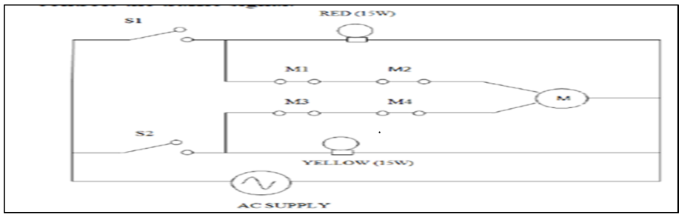

Fig: Circuit diagram

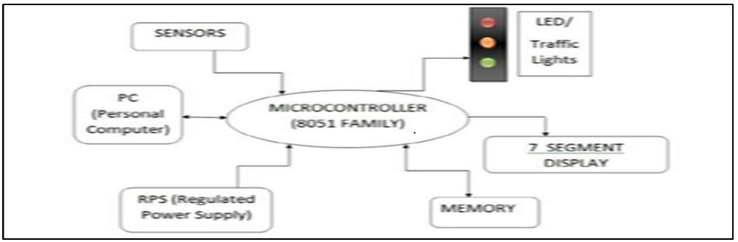

Fig: Sensor block diagram

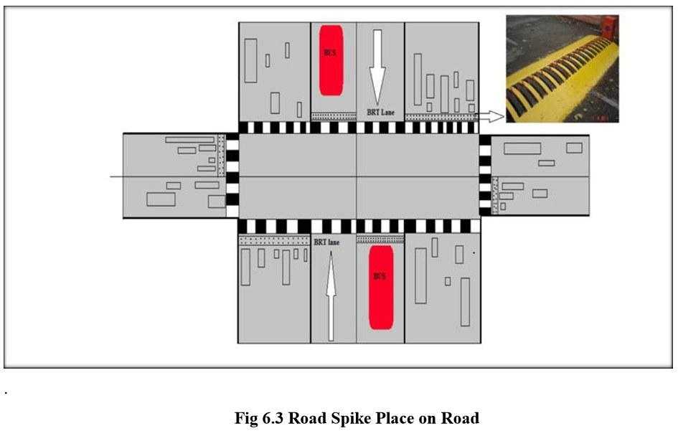

**4.4 Project requirements:** To complete this project successfully we need some requirements.

* Time: 6-7 month.
* Budget: 4,50,000 tk
* Active team with 6 members
* Perfect office environment.
* Spike, microcontroller, DC motor.
* Sensor

**5. Feature not to be tested:**

The features which will not be tested are as follows:

● Oracle database server support: As the users will directly not see this, cause this feature will not be tested. The modules will be developed in such a way which support the Oracle database.

● Maintenance of user records: As Oracle provides comprehensive discretionary access control no need to check for that at this moment.

● Source and Destination selection: Source and Destination will be fixed by the system development team.

**6. TESTING APPROACH:**

The approach of the testing process is a follow:

● In the beginning, all the test cases shall be derived using the current Program

Specification.

● Test suites will be prepared by assembling test cases.

● The system requirements and test cases shall be reviewed to verify the proper

operation of each unit.

● Testing tools such as Selenium, Katelin Studio, Test Complete will be used to

execute test cases and in the case of regression testing.

● Licenses for these testing tools will be purchased.

● As some of the tools require special training, workshops will be arranged.

● The results for each test shall be documented and shall be kept for future

verification.

● The tests process shall be performed manually and after that automated testing

will be conducted.

● Successful unit testing shall be done before the system is eligible for integration

testing or system testing.

● Identification of any new defect or bug and any unsuccessful testing shall be

reported directly to the developing team.

● Regression testing shall be used for verifying the modifications.

● If any modification or update is required in the system that shall be handled

immediately.

7.TEST CASES/TEST ITEMS

|  |  |  |  |  |  |
| --- | --- | --- | --- | --- | --- |
| Project Name: Road Spikes on Traffic Signal | | | Test Designed by: Rahikul Zannat | | |
| Test Case ID: FR_ 6.System control traffic signal light | | | Test Designed date: 19/9/2020 | | |
| Test Priority (Low, Medium, High): High | | | Test Executed by: Rahikul Zannat | | |
| Module Name: Light System | | | Test Execution date: 20/9/2020 | | |
| Test Title: Verify all lights | | |  | | |
| Description: Test website Signal page | | |  | | |
| Test Steps | Test Data | Expected Results | | Actual Results | Status (Pass/Fail) |
| 1. Go to the website 2. Click on light signal menu 3. Turn on off 4. Hold or walking pass light | Red,  yellow,  blue, green | All lights working  perfectly | | As expected, | Pass |

|  |  |  |  |  |  |
| --- | --- | --- | --- | --- | --- |
| Project Name: Road Spikes on Traffic Signal | | | Test Designed by: Rahikul Zannat | | |
| Test Case ID: FR_7 1. System control spike control unit | | | Test Designed date: 19/9/2020 | | |
| Test Priority (Low, Medium, High): High | | | Test Executed by: Rahikul Zannat | | |
| Module Name: Spike Control Session | | | Test Execution date: 22/9/2020 | | |
| Test Title: Testing Spikes control | | |  | | |
| Description: Test website Spike control page | | |  | | |
| Test Steps | Test Data | Expected Results | | Actual Results | Status (Pass/Fail) |
| 1.Go to the website  2.Click on Spike menu  3.Turn on Spike  4.Turn off spike  5.Spikes on with red lights | User id=2222  Password=111  Spikes Permission= Granted | Go to the page and control the spike system | | As expected, | Pass |

|  |  |  |  |  |  |
| --- | --- | --- | --- | --- | --- |
| Project Name: Road Spikes on Traffic Signal | | | Test Designed by: Rahikul Zannat | | |
| Test Case ID: FR_ 8. System control User | | | Test Designed date: 19/9/2020 | | |
| Test Priority (Low, Medium, High): High | | | Test Executed by: Rahikul Zannat | | |
| Module Name: User Control | | | Test Execution date: 21/9/2020 | | |
| Test Title: verify login with valid username and password | | |  | | |
| Description: Test website User interface | | |  | | |
| Precondition (If any): User must have valid username and password | | | | | |
| Test Steps | Test Data | Expected Results | | Actual Results | Status (Pass/Fail) |
| 1. Go to the website 2. Enter username 3. Enter password 4. Click submit | Username: 1010  Password: 333 | User should login into the application | | As expected, | Pass |
| Post Condition: User is validated with database and successfully login to account. The account session details are logged in the database. | | | | | |

**8. Item pass fail criteria:**

* When a test case satisfies the signatures and constraints of both the design specification and the system architecture, only then the tests executed on integrated components pass.
* If a test case fails to satisfy the constraints and signature of the design specification
* and the system architecture both, it will be reported to the developers to be fixed.
* A component only passes the test case when it satisfies all the constraints and signatures of the design specification of the document.
* When a test case fails to satisfy the constraints and signature of the design specification, it will be reported to the developers to be fixed.
* Tests executed against the system need to pass the functional requirements, nonfunctional requirements and use cases to pass.
* Tests will fail if any of the three criteria are said to be failed.

**9. Test deliverables:**

Every software application goes through different phases of SDLC and STLC. Test Deliverables are the test artifacts which are given to the stakeholders of a software project during the SDLC.

* Test Cases
* Test Plan Document
* Test Strategy
* Test Summary Report
* Test Defect Report
* Test Status Report
* Test Evaluation Report
* Error Corrective Actions
* Execution Log Files
* Summary

**10. Staffing and training needs:**

This is very sensitive project because end users are the normal public. So, all the members of the testing team have to done all the test perfectly. Tools such as Selenium, Katelin Studio, Test Complete will be used to execute test cases and in the case of regression testing. Members of the testing team might not be used to these tools. In this case, the Test Lead and Project Manager need to collaborate with administration personnel and train the members of the testing team.

**11. RESPONSIBILITIES**

* Define the test activities to all the test engineers and solve the problems what they facing during the test.
* Responsibilities should be ensured for all testing plan.
* Applying all the measurements correctly and development in every phase.
* Always checking the testing going right or wrong.
* Prepare and check the test report time to time that’s helps the testing accurately.
* Always do interaction with the customers and do meetings with them and discuss with them about the project requirements are doing in right way or not.
* Communication is very important. Communicate with the project manager regularly.
* Execute all the test cases and report defects, define severity and priority for each defect.
* Acceptance test documentation and execution should be check by the team manager, project manager, test team and client.
* System Design review should be review by everyone included in the project also client.
* Client did not have the access to check or review all the test situations. Only a few things that the client can review.
* Read and understand all the documented related to the project.
* Change control and regression testing is the last part of testing so it can be review by client and other stages member of the project.

**12. Testing Schedule**

Time and work have been identifying and given in within the deadline. In this given time and schedule project plan has been allocated. Scheduling is estimating all the time that took for the project. Manager give the time to the engineers and the start work on it and manager continuously have collect the record of timing that helps to estimating the budget how much time it took to complete the project.

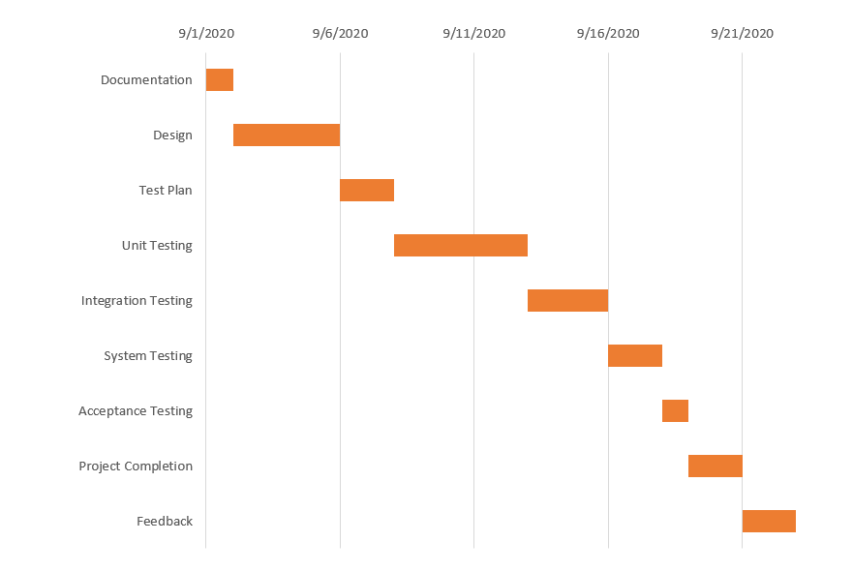

**13.Planing Risks and Contingencies**

The allocated time cannot be delayed. The testing schedule should be unchanged. If there are any problem comes up then the expected result should not be changed. In project working time there can be time scheduling problem faced by the manager then the deal line will change customer testing review will also change. That cannot be happened during the project scheduled timeline. If there are staff shortage then new staff appoint is time losing, he has to be understood what requirements the project need what he has to test that is time consuming.

**14. Approvals**

|  |  |
| --- | --- |
| Project Sponsor | ABHIJIT BHOWMIK |
| Development and Testing Team |  |
| Project Manager | Rahikul Zannat |